Lab Assessment Cos 102 - Problem solving
Project Assignment:
- Write a program to input two angles of a triangle and check whether the triangle is a right-angled triangle or not.

START
INPUT angle1
INPUT angle2

angle3 = 180 - (angle1 + angle2)
IF angle1 == 90 OR angle2 == 90 OR angle3 == 90 THEN
PRINT "Triangle is right-angled"
ELSE
PRINT "Triangle is NOT right-angled"
END IF
ENDSTART

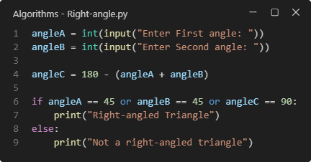
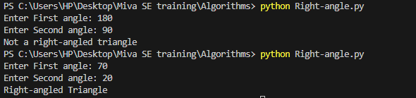

2. Write a program to find whether the given number is Palindrome or No

START
INPUT number

Original-Number = number
reverse = 0

WHILE number > 0 DO
digit = number MOD 10
reverse = (reverse * 10) + digit
number = number DIV 10
END WHILE

IF original == reverse THEN
PRINT "Palindrome"
ELSE
PRINT "Not Palindrome"
END IF
END

z
